Electronic label image production

In the test phase, you can manually create an image of the electronic label. The method of making it is as follows:

1. Make BMP format pictures

2. Convert BMP format images to bin format.

3. Converted BIN format picture to a JSON message.

# Make BMP format pictures

For 4.2-inch electronic tags, it is recommended that the supporting version of the base station be V1.3.

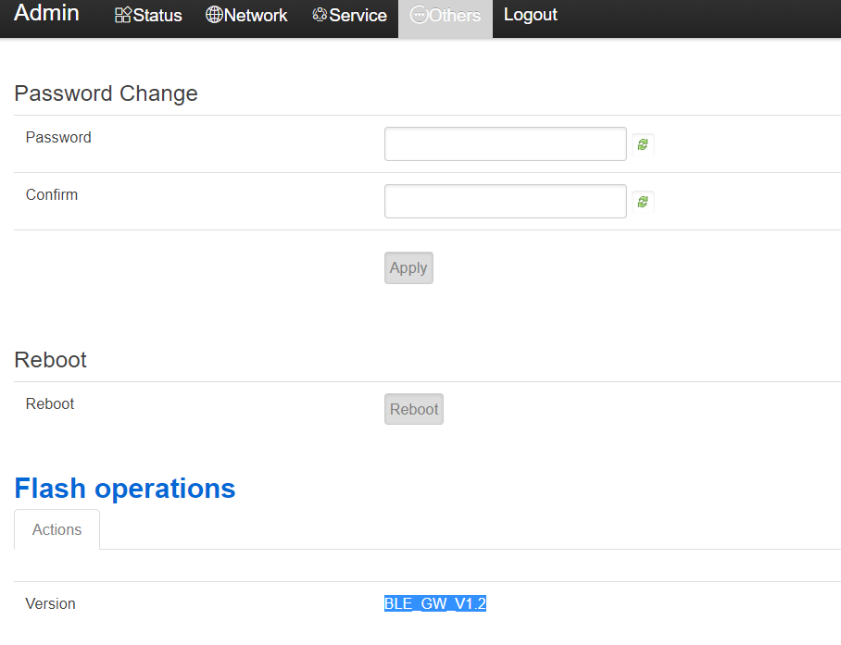

This screen does not support gray scale. When making pictures, you need to make a pure black and white picture with 400*300 resolutions.

The following uses the windows drawing tool as an example:

1, Windows attachment menu = "painting

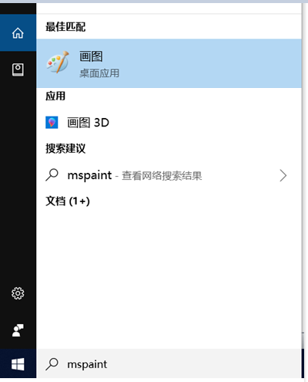

2. set the resolution to 400*300

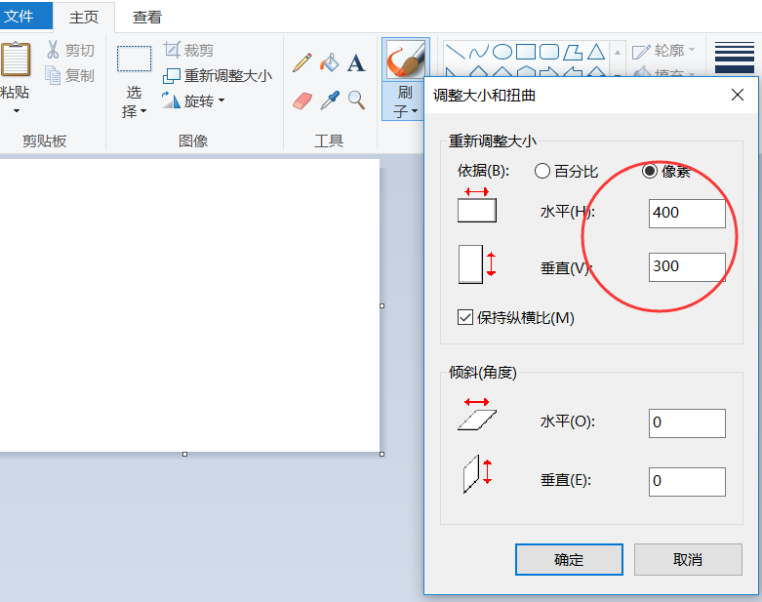

3. you can add text on the picture.

4. please select the single color bitmap to save.

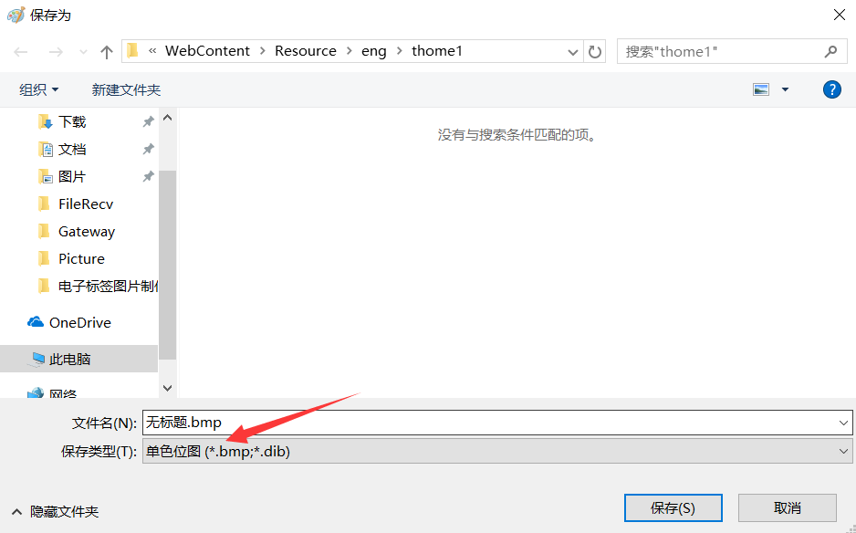

# Convert BMP format images to bin format

Through the third-party software image2lcd software, there is a zip inside the package, which contains the license.

The parameter setting interface is shown in Figure 2:

1. Open image2lcd and load the image that needs to be modulo.

2, the output data type: select "binary BIN";

3, scanning method: select "horizontal scanning";

4, output gray: select "monochrome";

5, the maximum width and height: select "400", "300", after selection, you need to click the arrow below to confirm



6, other menus on the left do not need to be checked.

7, positive display (black on white), then "color reversal" check;

8. Click "Save" to save the converted array to the extension "bin file;

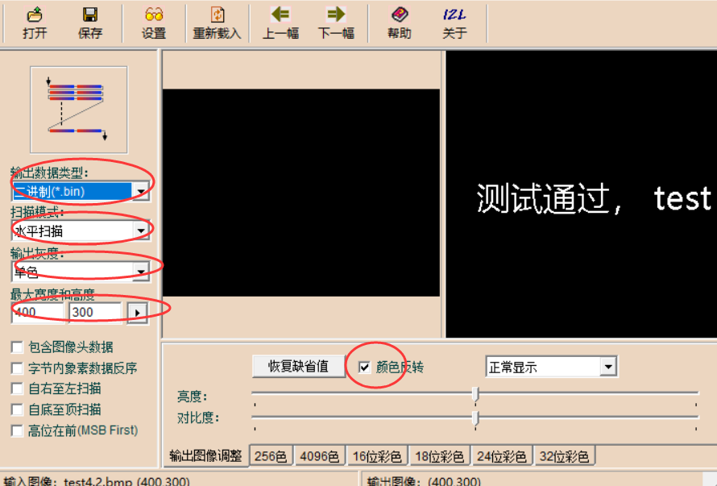

# Converted BIN format picture to a JSON message

1. Please put the BIN image file generated in the previous step and Bin2Json.exe in the same directory.

2, run the Bin2Json.exe tool, the parameters you need to enter are as follows:

a) BIN file name.

b) The password of the tag, the default is 8 ASCII zero, “00000000”

c) The mac address of the device can be viewed through the Gateway status monitoring to the 12-character mac address.

d) The ID of the picture, you can enter a number arbitrarily, this is equivalent to the number of this picture.

e) Using zip format, for 4.2-inch labels, compression is recommended for reduce the picture download time.

After the carriage return, you will be prompted to write the JSON file successfully. You can see that a file named lcd42_examp1.json is generated in the same directory, which is the image update message.

Bin2Json.exe is based on Visual Studio 2012 written in C language. The source code can be downloaded at the following URL:

https://github.com/kkmhogen/ESLBin2Json.git

